** EAST WEST UNIVERSITY**

**Experiment No:** 03

**Course Code:** ICE470

**Course Title:** Numerical Method Lab

**Experiment Name:** Performing Newton Raphson method

in finding roots of any equation using MATLAB.

**Submitted To:**

Mr. Rasel Ahmmed  
 Lecturer, Department of ECE

**Submitted by:**

Md. Tariqul Islam  
**ID NO:** 2014-2-50-021

**Date of Performance**: 24.05.2018

**Date of Submission:** 30.05.2018

**Experiment No: 03**

**Experiment Name:** Performing Newton Raphson method in finding roots of any equation using MATLAB.

**Objective:**

**1.** To perform Newton Raphson method in finding roots of any equation using MATLAB.

**2.** To compare the real error and estimated approximate error using MATLAB.

**1. Matlab Code :**

clc;

clear all;

close all;

%newton-Rapshon Method

%a method for solving f(x)=0

xo=input('Enter the initial value (0.1): ');

maxiter=input('Enter the value of iteration(25): ');

pst=input('Enter the value of acceptable error(0.0001): ');

x=xo;

xold=xo;

fori=1:maxiter

f=cos(x)-(x.^2)+20;

df=-sin(x)-2*x;

x=x - (f/df);

e=abs((x-xold)*100/x);

xold=x;

if( i==1 || i==3 || i++5 || i==7 || i==9)

fprintf('Approximate error =% f''\n' ,e );

end

y(i,:)=e;

v(i,:)=i;

if (e<=pst)

break;

end

end

fprintf('root of the function by using newton-raphson method=% f''\n' ,x);

fprintf('number of iteration=% f''\n' ,i);

fprintf('Approximate error = % f''\n' ,e );

clc

close all

clear all

v= [1 3 5 7 9]

y= [99.857324 99.009083 62.783449 3.971502 0.000033]

plot(v,y,'r--*');

xlabel('Number of iteration');

ylabel('approximate error');

title('"approximate error" vs "No of iteration taken"');

grid on

**Command Window :**

v =

1 3 5 7 9

y =

99.8573 99.0091 62.7834 3.9715 0.0000

**Figure :**

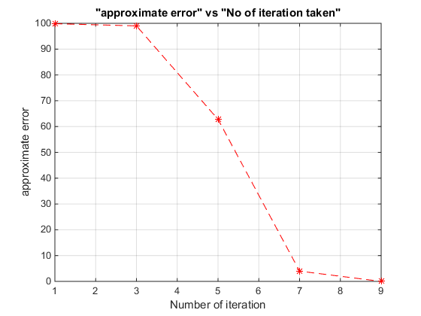

**2. Matlab Code (Practice) :**

clc;

clear all;

close all;

%newton-Rapshon Method

%a method for solving f(x)=0

xo=input('Enter the initial value (0.1): ');

maxiter=input('Enter the value of iteration(25): ');

pst=input('Enter the value of acceptable error(0.0001): ');

x=xo;

xold=xo;

fori=1:maxiter

f=(x.^2)+(2*x)-2;

df=2*x+2;

x=x - (f/df);

e=abs((x-xold)*100/x);

xold=x;

if( i==1 || i==3 || i++5 || i==7 || i==9)

fprintf('Approximate error =% f''\n' ,e );

end

y(i,:)=e;

v(i,:)=i;

if (e<=pst)

break;

end

end

fprintf('root of the function by using newton-raphson method=% f''\n' ,x);

fprintf('number of iteration=% f''\n' ,i);

fprintf('Approximate error = % f''\n' ,e );

clc

close all

clear all

v= [1 3 5 7 9]

y= [99.857324 99.009083 62.783449 3.971502 0.000033]

plot(v,y,'r--*');

xlabel('Number of iteration');

ylabel('approximate error');

title('"approximate error" vs "No of iteration taken"');

grid on

**Command Window :**

v =

1 3 5 7 9

y =

99.8573 99.0091 62.7834 3.9715 0.0000

**Figure 1 :   
  
**

**Discussion:** This experiment name is Performing Newton Raphson method in finding roots of any equation using MATLAB. There are two program codes. A equation was given by which i had perform the code.

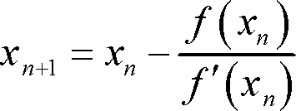

This is the Newton-Raphson Method of finding roots.

This is recursive algorithm because a set of steps are repeated with the previous answer put in the next repetitiom. Each repetition is called an iteration.

The Newton Raphson method is based on the principle that if the initial guess of the root of f(x)=0 is at C:\Users\MUNMUN-1\Desktop\ICE 456\Capture.JPG then if one draws the tangent to the curve at C:\Users\MUNMUN-1\Desktop\ICE 470\Capture.JPG,the point C:\Users\MUNMUN-1\Desktop\ICE 456\Capture 1.JPG where the tangent crosses the x-axis is an improved estimate of the root. General form of problem: find an x such that f(x) = 0.

In the first program code, the given equation was differentiated then applied Newton Raphson method. I wrote the program code in MATLAB then save the program in a folder and ran it. Then the command window asks the value of initail value, iteration value and value of acceptable error. As a user I put the value of initital value 0.1, value of iteration 25 and value of acceptable error 0.0001. Command window asks to put value because there is a command name input. After giving the value The result shows a figure in which there is the value of v and y. In the program code there is a plot command which is use to plot the graph of the given function, grid on is use to display axes grid lines. In the figure x-axis is number of iteration and y axis is approximate error.

In the second program code, the given equation was differentiated then applied Newton Raphson method. The second program code is similar to the first program code. But the equation was different and the value of x for positive 0.732, for negative -2.73. When I take the initial value .1, iteration 25, error 0.0001 then the the value of x exist only positive but if I take initial value -5.32, iteration 100 and error 0.0001 then the value of y exist for negative. Negative and positive value depends on the limitation of initail value. Afetr performing the code the result shows the value of v, y and the figure. In the figure, it marks the value of v and y properly.

The title of the figure is approximate error vs no of iteration error.